**Functional Document**

|  |  |
| --- | --- |
| **Application** | NGERP - Centra |
| **Service Bundle** | Sales Management |
| **Service Request** | Super Payment |

**Description:**

In **Compiere (NGERP-Centra)**, the Super Payment feature is used to void payment transactions, which helps in adjusting and posting financial records accurately.

**Workflow Process:**

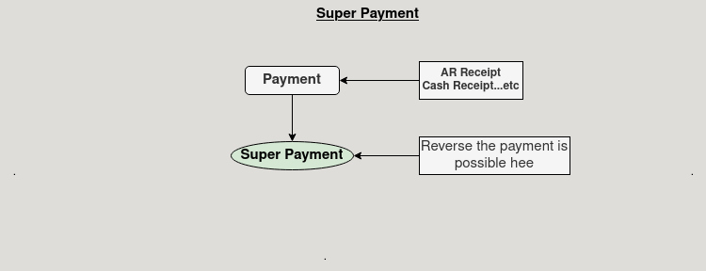

**Business Rules:**

* It is visible in both **HQ** and **ROW.**
* In **ROW ,** Created Payments (**AR Receipt, Cash Receipt**) will be shown.
* **Voiding** the payments is possible in **ROW.**
* In **HQ** show all region payments (**AR Receipt**, **Cash Payment**).
* In **Super Payment** Screen in **ROW** , **reverse** payment is possible.